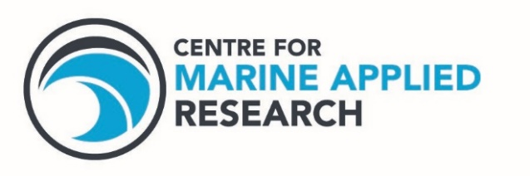

V2

**ADCP Report**

**Location: Station Name, Waterbody**

**Deployment Date: yyyy-mm-dd**

June 2022

Prepared by:

Danielle Dempsey

Kiersten Watson

Leah Lewis-McCrea

Joseph Barss

27 Parker Street **·** Dartmouth, Nova Scotia **·** B2Y 4T5

CMAR.CA